Task 1 — Enable Azure Monitor (4 Marks)
Task 1.1 — Enable Monitoring on Your Virtual Machine (2 Marks)
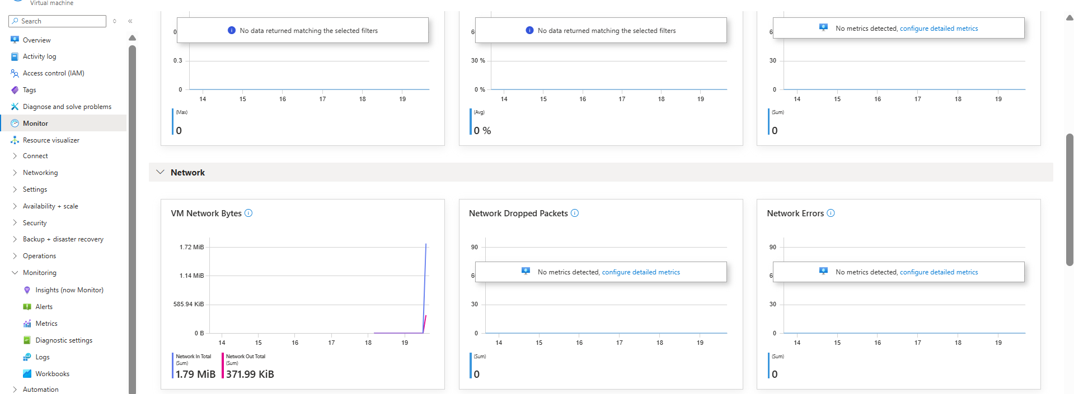
This picture shows the general monitoring that can be seen on the overview page of the VM, it tracks a multitude of stats

Task 1.2 — Enable Monitoring on Network Resources (2 Marks)

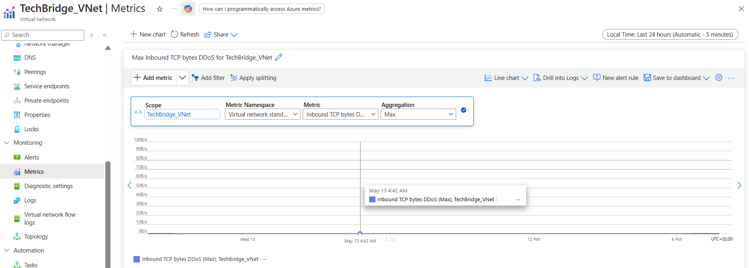
VNET

This is the Metrics for the VNET in this case its measuring Inbound TCP bytes DDoS

NSG
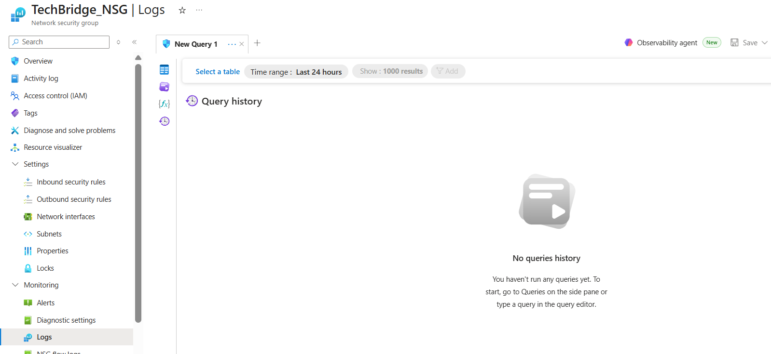
Task 2 — Review Key Metrics (3 Marks)
Task 2.1 — CPU Metrics
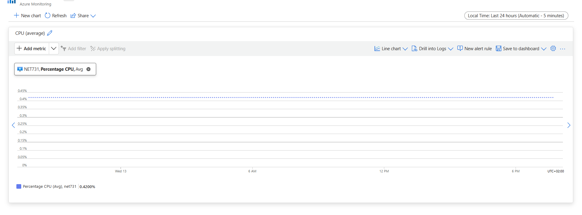
CPU Metrics of the VM
Task 2.2 — Network Metrics
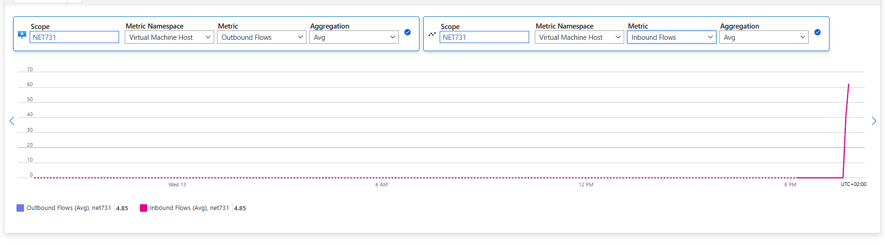

Network metrics of the VM

Task 2.3 — Disk Metrics
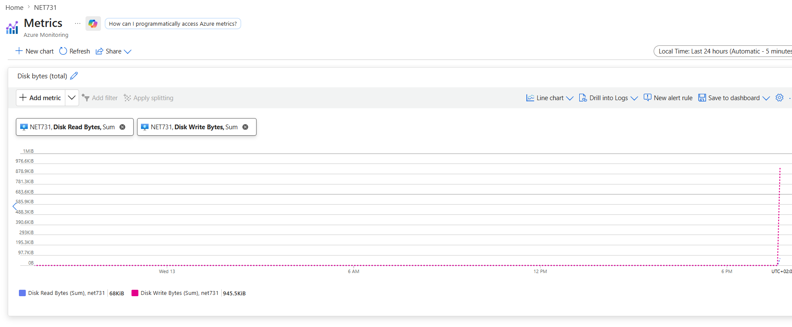
Disk Metrics of the VM
Task 3.1 — Monitoring Summary (2 Marks)
Resources Monitored:
I monitored a VM’s, CPU, disk space and It’s network traffic with azure monitors metric tool. I also monitored a VNET also using azure monitor’s metric tool, I choose a metric randomly to see if it would have any traffic on it, Also looked at NSG logs
Metric Observations
Metrics seemed normal, although I has limited data to work off of

Task 3.2 — Extension: Configure an Alert Rule (1 Bonus Mark)
